CYCLE – 5

1) Program to draw Circle, Rectangle, Line in Applet.

Circle_Line.java

import java.applet.*;
import java.awt.*;
public class CircleLine extends Applet
{
int x=300,y=100,r=50;
public void paint(Graphics g)
{
System.out.println("Name: Ashin Siby");
g.drawLine(3,300,200,10);
g.drawString("Line",100,100);
g.drawOval(x-r,y-r,100,100);
g.drawString("Circle",275,100);
g.drawRect(400,50,200,100);
g.drawString("Rectangel",450,100);
}
}

CircleLine_index.html

<HTML>
<HEAD>
</HEAD>
<BODY>
<div align="center">
<APPLET CODE="CircleLine.class" WIDTH="800" HEIGHT="500"></APPLET>
</div>
</BODY>
</HTML>

Output
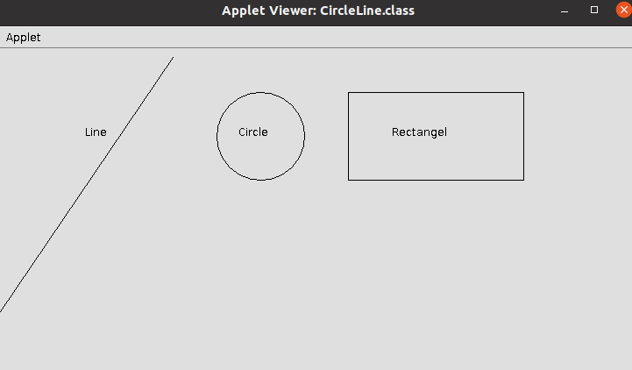

2) Program to find maximum of three numbers using AWT.

MaxNumberFinder.java

import java.awt.*;
import java.awt.event.ActionEvent;
import java.awt.event.ActionListener;

public class MaxNumberFinder extends Frame {
private TextField num1Field, num2Field, num3Field;
private Label resultLabel;

public MaxNumberFinder() {
setTitle("Max Number Finder");
setSize(300, 200);
setLayout(new FlowLayout());

Label num1Label = new Label("Number 1: ");
num1Field = new TextField(10);
add(num1Label);
add(num1Field);

Label num2Label = new Label("Number 2: ");
num2Field = new TextField(10);
add(num2Label);
add(num2Field);

Label num3Label = new Label("Number 3: ");
num3Field = new TextField(10);
add(num3Label);
add(num3Field);

Button findButton = new Button("Find Max");
add(findButton);

resultLabel = new Label("");
add(resultLabel);

findButton.addActionListener(new ActionListener() {
@Override
public void actionPerformed(ActionEvent e) {
int num1 = Integer.parseInt(num1Field.getText());
int num2 = Integer.parseInt(num2Field.getText());
int num3 = Integer.parseInt(num3Field.getText());

int max = Math.max(num1, Math.max(num2, num3));

resultLabel.setText("Max Number: " + max);
}
});

setVisible(true);
}

public static void main(String[] args) {
new MaxNumberFinder();
}
}

Output

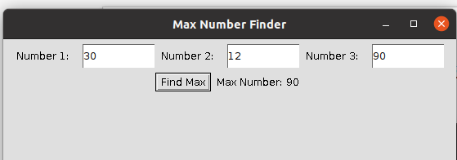

3. Find the percentage of marks obtained by a student in 5 subjects. Display a happy face if he secures above 50% or a sad face if otherwise.

Q3.java

import java.applet.*;
import java.awt.*;
import java.awt.Graphics;
import java.awt.event.*;

public class Q3 extends Applet implements ActionListener {
Label l1,l2,l3,l4,l5,l6;
TextField t1,t2,t3,t4,t5,t6;
Button b;
public void init(){
l1 = new Label("MARK 1:");
t1 = new TextField();
l2 = new Label("MARK 2:");
t2 = new TextField();
l3 = new Label("MARK 3:");
t3 = new TextField();
l4 = new Label("MARK 4:");
t4 = new TextField();
l5 = new Label("MARK 5:");
t5 = new TextField();
l6 = new Label("PERCENTAGE:");
t6 = new TextField();

b = new Button("SEE STATUS");

setLayout(null);

l1.setBounds(450,50,70,20);
t1.setBounds(520,50,100,20);
l2.setBounds(450,80,70,20);
t2.setBounds(520,80,100,20);
l3.setBounds(450,110,70,20);
t3.setBounds(520,110,100,20);
l4.setBounds(450,140,70,20);
t4.setBounds(520,140,100,20);
l5.setBounds(450,170,70,20);
t5.setBounds(520,170,100,20);
l6.setBounds(450,200,100,20);
t6.setBounds(550,200,100,20);

b.setBounds(450,290,80,30);

add(l1);
add(l2);
add(l3);
add(l4);
add(l5);
add(l6);
add(t1);
add(t2);
add(t3);
add(t4);
add(t5);
add(t6);
add(b);
b.addActionListener(this);

}
public void actionPerformed(ActionEvent e){
float m1, m2,m3, m4,m5,percent;

m1= Float.parseFloat(t1.getText());
m2= Float.parseFloat(t2.getText());
m3= Float.parseFloat(t3.getText());
m4= Float.parseFloat(t4.getText());
m5= Float.parseFloat(t5.getText());

percent=((m1+m2+m3+m4+m5)*100)/500;

t6.setText(String.valueOf(percent));
repaint();
}

public void paint(Graphics g){

float p;
p= Float.parseFloat(t6.getText());

if(p> 50.0) {
g.setColor(Color.YELLOW);
g.fillOval(0,0,100,100);
g.setColor(Color.black);
g.fillOval(25,25,10,10);
g.fillOval(65,25,10,10);
g.setColor(Color.black);
g.fillArc (25,35,50,50,0,-180);
}
else {
g.setColor(Color.YELLOW);
g.fillOval(0,0,100,100);
g.setColor(Color.black);
g.fillOval(25,25,10,10);
g.fillOval(75,25,10,10);
g.setColor(Color.black);
g.drawArc(25,35,50,50,0,180);
}
}
}

Q3_index

<HTML>
<HEAD>
</HEAD>
<BODY>
<div align="center">
<APPLET CODE="Q3.class" WIDTH="800" HEIGHT="500"></APPLET>
</div>
</BODY>
</HTML>

Output
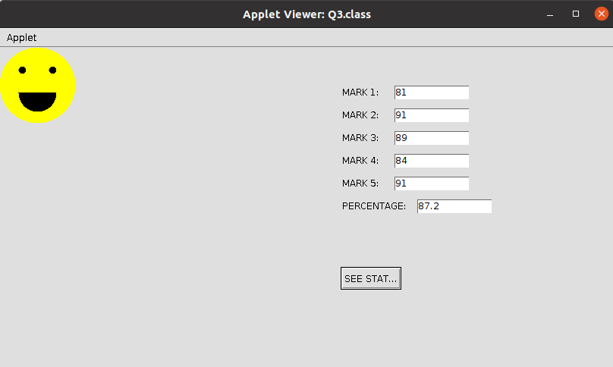

4. Using 2D graphics commands in an Applet, construct a house. On mouse click event, change the color of the door from blue to red.

House.java

import java.awt.*;
import java.applet.*;
import java.awt.event.*;
public class House extends Applet implements MouseListener
{
int a,b;
public void init()
{
addMouseListener( this);
}
public void paint(Graphics g)
{
int x[]={150,300,225};
int y[]={150,150,25};
g.drawPolygon(x,y,3);
g.setColor(Color.GRAY);
g.fillPolygon(x,y,3);

g.drawRect(150,150,150,200);//House
g.setColor(Color.CYAN);
g.fillRect(150,150,150,200);

g.drawRect(200,200,50,150);//Door
g.setColor(Color.blue);
g.fillRect(200,200,50,150);

if(a>200 && a<300 && b>200 && b<300)
{
g.setColor(Color.red);
g.fillRect(200, 200, 50, 150);
}
}
public void mouseClicked(MouseEvent e)
{
}
public void mouseEntered(MouseEvent e)
{
}

@Override
public void mouseExited(MouseEvent e) {
}

public void mousePressed(MouseEvent e)
{
a=e.getX();
b=e.getY();
repaint();
}
public void mouseReleased(MouseEvent e)
{
}
}

House_index.html

<html>
<body>
<applet code="House.class" width="600" height="600">
</applet>
</body>
</html>

Output
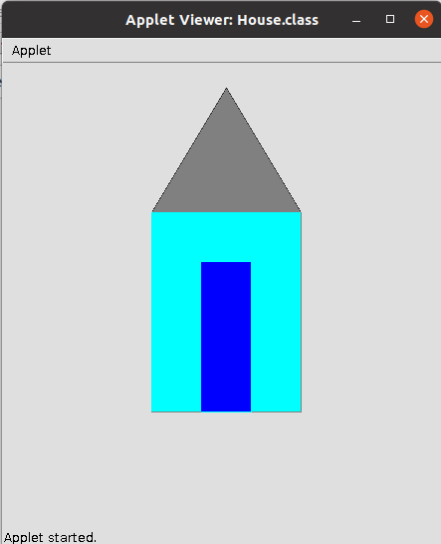

5. Implement a simple calculator using AWT components.

Calculator.java

import java.awt.*;
import java.awt.event.*;
public class Calculator implements ActionListener
{
Frame f=new Frame();
Label l1=new Label("First Number");
Label l2=new Label("Second Number");
Label l3=new Label("Result");
TextField t1=new TextField();
TextField t2=new TextField();
TextField t3=new TextField();
Button b1=new Button("Add");
Button b2=new Button("Sub");
Button b3=new Button("Mul");
Button b4=new Button("Div");
Button b5=new Button("Cancel");
Calculator()
{
l1.setBounds(50,100,100,20);
l2.setBounds(50,140,100,20);
l3.setBounds(50,180,100,20);
t1.setBounds(200,100,100,20);
t2.setBounds(200,140,100,20);
t3.setBounds(200,180,100,20);
b1.setBounds(50,250,50,20);
b2.setBounds(110,250,50,20);
b3.setBounds(170,250,50,20);
b4.setBounds(230,250,50,20);
b5.setBounds(290,250,50,20);
f.add(l1);
f.add(l2);
f.add(l3);
f.add(t1);
f.add(t2);
f.add(t3);
f.add(b1);
f.add(b2);
f.add(b3);
f.add(b4);
f.add(b5);
b1.addActionListener(this);
b2.addActionListener(this);
b3.addActionListener(this);
b4.addActionListener(this);
b5.addActionListener(this);
f.setLayout(null);
f.setVisible(true);
f.setSize(400,350);
}
public void actionPerformed(ActionEvent e)
{
int n1=Integer.parseInt(t1.getText());
int n2=Integer.parseInt(t2.getText());
if(e.getSource()==b1)
{
t3.setText(String.valueOf(n1+n2));
}
if(e.getSource()==b2)
{
t3.setText(String.valueOf(n1-n2));
}
if(e.getSource()==b3)
{
t3.setText(String.valueOf(n1*n2));
}
if(e.getSource()==b4)
{
t3.setText(String.valueOf(n1/n2));
}
if(e.getSource()==b5)
{
System.exit(0);
}
}
public static void main(String...s)
{
new Calculator();
}
}

Output
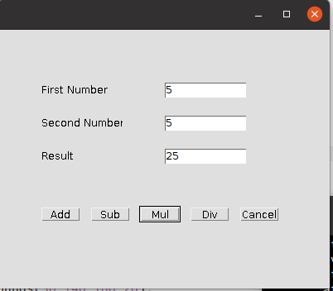

6. Develop a program that has a Choice component which contains the names of shapes such as rectangle, triangle, square and circle. Draw the corresponding shapes for given parameters as per user’s choice.

Main.java

import java.applet.*;
import java.awt.*;
import java.awt.Graphics;
import java.awt.event.*;
public class Main extends Applet implements ItemListener
{
Choice figure = new Choice();
int Select;
public void init()
{
figure.addItem("Select your choice");
figure.addItem("Rectangle");
figure.addItem("Square");
figure.addItem("Circle");
figure.addItem("Triangle");
add(figure);
figure.addItemListener(this);
}
public void itemStateChanged (ItemEvent e)
{
Select = figure.getSelectedIndex();
repaint();
}
public void paint(Graphics g)
{
g.setColor(Color.red);
super.paint(g);

if (Select == 1)
{

g.drawRect(280, 100, 160,40);
}
if (Select == 2)
{
g.drawRect(50,50,100,100);
}
if (Select == 3)
{

g.drawOval(150,150,100,100);
}
if (Select ==4)
{
g.drawLine(120, 130, 280, 130);
g.drawLine(120, 130, 200, 65);
g.drawLine(200, 65, 280, 130);
}
}
}

Output

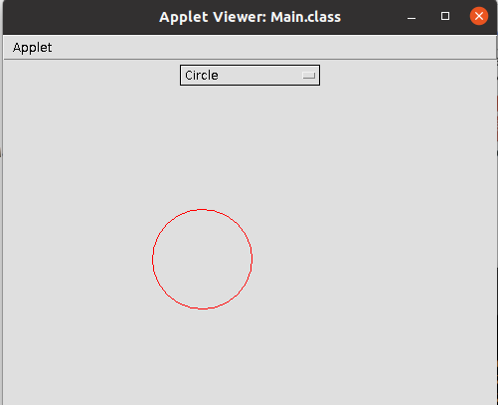

7. Develop a program to handle all mouse events and window events

Mouseevents.java

import java.awt.*;
import java.awt.event.*;
public class Mouseevents extends Frame implements MouseListener{
Label l;
Mouseevents(){
addMouseListener(this);
l=new Label();
l.setBounds(20,50,100,20);
add(l);
setSize(300,300);
setLayout(null);
setVisible(true);
}
public void mouseClicked(MouseEvent e) {
l.setText("Mouse Clicked");
}
public void mouseEntered(MouseEvent e) {
l.setText("Mouse Entered");
}
public void mouseExited(MouseEvent e) {
l.setText("Mouse Exited");
}
public void mousePressed(MouseEvent e) {
l.setText("Mouse Pressed");
}
public void mouseReleased(MouseEvent e) {
l.setText("Mouse Released");
}
public static void main(String[] args) {
new Mouseevents();
}
}

Output
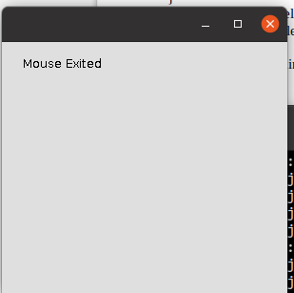

8. Develop a program to handle Key events.

KE.java

import java.awt.FlowLayout;
import java.awt.Frame;
import java.awt.Label;
import java.awt.TextField;
import java.awt.event.KeyEvent;
import java.awt.event.KeyListener;
public class KE implements KeyListener
{
Label lb1, lbl2, lb;
TextField tf1;
Frame fr;
String s;
KE()
{
fr = new Frame("KeyEventListener Example");
lb1= new Label(" Key Events will be displayed based on the actions",
Label.CENTER);
lbl2= new Label();
lb= new Label();
tf1 = new TextField(20);
fr.setLayout(new FlowLayout());
fr.add(lb1);
fr.add(tf1);
fr.add(lbl2);
tf1.addKeyListener(this);
fr.setSize(460,250);
fr.setVisible(true);
}
public void keyPressed(KeyEvent ev)
{

lbl2.setText(" Key pressed");
}
public void keyReleased(KeyEvent ev)
{
lbl2.setText("Released");
}
public void keyTyped(KeyEvent ev)
{
lbl2.setText("Key is typed");
fr.setVisible(true);
}
public static void main(String[] args)
{
new KE();
}
}

Output

